 **KGiSL Institute of Technology**

(Affiliated to ANNA University, Chennai and Approved by AICTE, New Delhi)

365, KGiSL Campus, Thudiyalur Road, Saravanampatti Coimbatore – 641035

**Department of Artificial**

**Intelligence and Data Science**



**NAAN MUDHALVAN -INTERNET OF THINGS**

PROJECT TITLE : ENVIRONMENTAL MONITORING IN PARKS

REGISTER NUMBER : 711721243008

NAME :AKASH.A

GMAIL ID : akash.a2021@kgkite.ac.in

MENTOR : MOHANKUMAR.M

EVALUATOR : AKILANDESWARI.M

**ENVIRONMENTAL MONITORING IN PARKS**

**Project Objectives:**

The primary objectives of the environmental monitoring project in parks are to assess and manage the ecological health and quality of park environments. This involves collecting and analyzing data to gain insights into various environmental factors, such as air quality, soil conditions, temperature, humidity, and water quality. The project aims to:

* Monitor and maintain the ecological balance of the park's environment.
* Ensure the safety and well-being of park visitors.
* Collect and analyze environmental data to inform decision-making and policies for park management.
* Promote sustainability and reduce the park's environmental footprint.

**IoT Device Deployment:**

IoT (Internet of Things) devices are deployed throughout the park to gather real-time data. These devices can include sensors and data collection equipment such as:

* Weather stations to monitor temperature, humidity, wind speed, and precipitation.
* Air quality sensors to measure pollutants like CO2, PM2.5, and volatile organic compounds.
* Soil moisture and nutrient sensors to assess soil conditions.
* Water quality sensors for monitoring streams, lakes, and groundwater.
* Wildlife tracking devices to monitor animal movements.

These devices are strategically placed in various locations within the park to ensure comprehensive data collection.

**Platform Development:**

The core of the project revolves around the development of a robust IoT platform that enables data collection, storage, analysis, and visualization. The platform should provide the following functionalities:

* Data Collection: It should receive data from IoT devices in real-time and store it in a database for further processing.
* Data Analysis: The platform should analyze the collected data to detect patterns, anomalies, and trends, enabling park authorities to make informed decisions.
* Alerts and Notifications: Implement an alert system to notify park rangers or administrators of critical issues or abnormal environmental conditions.
* Data Visualization: Develop a user-friendly dashboard or visualization tools that display data in a comprehensible format, such as charts, maps, and graphs.
* Data Reporting: Generate periodic reports and summaries to track the park's environmental health over time.
* Integration with Park Management Systems: Integrate the environmental monitoring platform with existing park management systems to facilitate decision-making.

**Code Implementation:**

The code implementation for environmental monitoring in parks would involve a combination of software and firmware development. Here's a high-level overview of the code components:

* IoT Device Firmware: Develop firmware for IoT devices to collect data, establish communication protocols, and transmit data securely to the central platform.
* Data Ingestion: Create code to receive and ingest data from IoT devices. This code should handle data validation and normalization.
* Data Storage: Develop code for database management to store incoming data efficiently. Common databases like PostgreSQL or NoSQL databases may be used.
* Data Analysis: Write algorithms and code for data analysis, including statistical analysis, anomaly detection, and pattern recognition.
* Alerts and Notifications: Implement code to send alerts and notifications through email, SMS, or push notifications when predefined thresholds are breached.
* Data Visualization: Build a user interface or dashboard to visualize data using web technologies (HTML, CSS, JavaScript) or dedicated data visualization libraries.
* Reporting: Create code to generate automated reports on environmental conditions and trends.
* Security: Ensure robust security measures to protect data, including encryption and authentication.
* Integration: Develop code for integrating the environmental monitoring system with other park management systems or external services.
* Maintenance and Updates: Continuously update and maintain the codebase to ensure optimal performance and adapt to changing environmental conditions and technological advancements.

An environmental monitoring project in parks involves deploying IoT devices, developing a comprehensive platform, and implementing code to collect, analyze, and visualize environmental data for informed decision-making and management of the park's ecosystem.

**Block Diagram:**

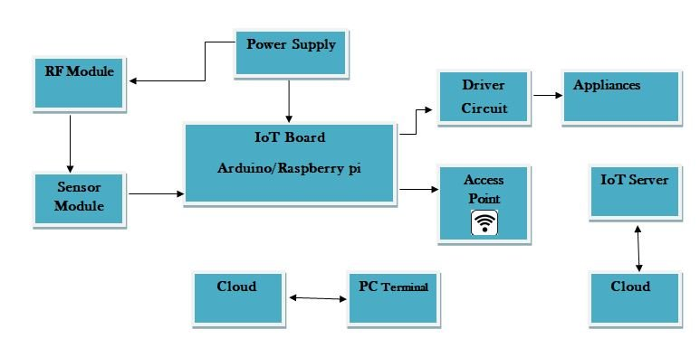

A block diagram is a high-level graphical representation of the various components and their interactions within an IoT device or system. In the context of IoT devices, a typical block diagram might look like this:

**Microcontroller (MCU):** This is the central processing unit of the IoT device. It controls all device functions, interacts with sensors, and manages data processing and communication.

**Sensors:** Various sensors are connected to the MCU to collect environmental data, such as temperature, humidity, motion, light, or gas levels.

**Communication Module:** This component enables the IoT device to connect to a network, typically through Wi-Fi, Bluetooth, cellular, LoRa (Long Range), or other communication protocols.

**Power Supply**: The power supply provides the necessary electrical energy to operate the IoT device. It can be a battery, a solar panel, or an external power source.

**Schematics of IoT Devices:**

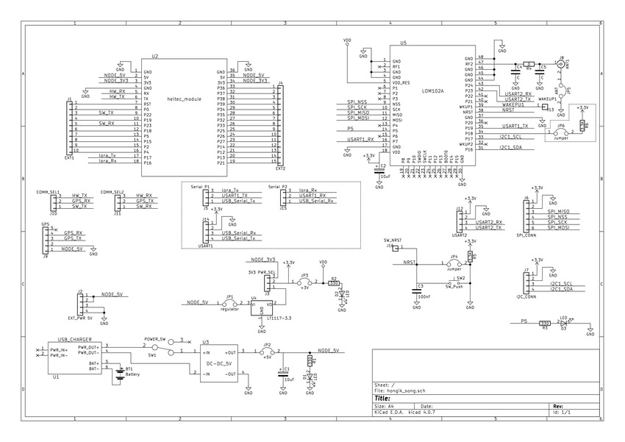

Schematics of IoT devices, often referred to as electronic schematics or circuit diagrams, are visual representations of the electrical and electronic components within the IoT device and how they are interconnected. These schematics use standardized symbols and lines to illustrate the physical and electrical relationships between components. Schematics are essential for understanding, designing, and troubleshooting the electronic circuits in IoT devices. Key components of an IoT device schematic may include microcontrollers, sensors, communication modules, power supplies, memory storage, and various peripherals.

Schematics provide a detailed and precise technical description of the IoT device's internal architecture, showing how signals and power flow between components. They are essential for electronics engineers and designers when developing, manufacturing, or repairing IoT devices.

**Screenshot:**

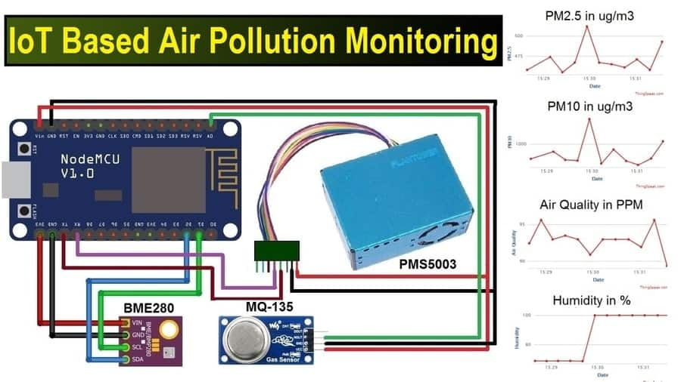

**Environmental Monitoring Platform:**

* **Data Ingestion Layer:** This component receives data from IoT devices, validates it, and normalizes it before storage.
* **Database:** Data is stored in a database, which could be represented as a large data storage system. Popular choices include PostgreSQL or NoSQL databases.
* **Data Analysis and Alert Engine:** Data analysis algorithms are implemented to detect anomalies and trends. When a critical event occurs, an alert is generated and sent out.
* **Data Visualization Dashboard:** The dashboard displays real-time and historical data through charts, graphs, and maps. Users can interact with the system to view specific data points.

**Data Display:**

* **Real-time Data Dashboard:** The dashboard displays real-time data from various sensors. It can include widgets showing current weather conditions, air quality index, soil moisture, and other parameters.
* **Historical Data Charts:** Charts and graphs can show historical trends and changes in environmental conditions over time. This can help in decision-making and long-term planning.
* **Alert Notifications:** Users receive notifications when predefined thresholds are breached, and these alerts can be displayed on the dashboard or sent through email, SMS, or mobile app notifications.

For creating diagrams, schematics, and screenshots, you can use various software tools or libraries such as Microsoft Visio, draw.io, Lucidchart, Grafana (for data visualization), and others. These tools can help you visually represent the architecture and components of your environmental monitoring system**.**

**Real-time environmental monitoring:**

A real-time environmental monitoring system in parks offers numerous benefits to both park visitors and the promotion of outdoor activities, enhancing the overall park experience. Here's how this system benefits park visitors and encourages outdoor engagement:

* **Safety Assurance:** Real-time monitoring of environmental conditions, such as weather, air quality, and soil moisture, ensures that park visitors are well-informed about potential risks. This knowledge allows them to make safer decisions, such as avoiding extreme weather or unhealthy air quality, reducing accidents and health hazards.
* **Informed Planning:** Visitors can access real-time data to plan their park activities. They can check weather conditions, temperature, precipitation, and other factors, enabling them to choose suitable activities for the day. For example, they can opt for hiking, picnicking, or water sports based on the current environmental data.
* **Optimal Outdoor Experiences**: By using real-time data, visitors can maximize their outdoor experiences. For instance, they can plan a picnic when the weather is pleasant, go bird-watching when bird activity is high, or engage in gardening when soil moisture levels are ideal.
* **Wildlife Viewing:** Wildlife enthusiasts benefit from real-time wildlife tracking data. They can receive updates on the movements and behavior of animals within the park, making it easier to spot and observe wildlife. This promotes wildlife conservation and appreciation.
* **Education and Awareness:** Real-time environmental data can be used for educational purposes. Interpretive signs, smartphone apps, or visitor centers can provide information about the park's ecosystems, climate, and geology. This fosters environmental awareness and encourages visitors to become stewards of the park.
* **Community Engagement:** A monitoring system encourages community engagement among park visitors. Shared access to environmental data can lead to discussions, knowledge-sharing, and collaboration on how to protect and enhance the park's environment.
* **Health and Well-being:** Access to air quality data encourages park-goers to prioritize their health. Clean air and safe environmental conditions promote physical activity and overall well-being.
* **Real-Time Alerts:** The system can provide timely alerts in the case of extreme conditions like storms, wildfires, or natural disasters. Visitors can take swift action to ensure their safety, which is particularly important for outdoor enthusiasts.
* **Sustainable Practices:** Real-time data can inspire visitors to adopt eco-friendly practices, including proper waste disposal, water conservation, and the protection of wildlife habitats. This fosters a sense of responsibility and stewardship toward the environment.
* **Improved User Experience:** Visitors seek enjoyable and comfortable experiences when outdoors. Real-time data allows park authorities to manage the park better, ensuring that facilities are well-maintained and that visitor needs are met, contributing to overall satisfaction.

**Conclusion:**

A real-time environmental monitoring system significantly enhances the park experience for visitors by promoting safety, informed decision-making, educational opportunities, and sustainable practices. This not only enriches the visitor experience but also deepens the connection between people and the environment, encouraging responsible outdoor activities and fostering a sense of stewardship towards our natural spaces. Ultimately, these systems play a pivotal role in creating a harmonious balance between human recreation and the preservation of our natural resources in parks.